SOFA: The HRTF Format
Piotr Majdak, Hagen Wierstorf

Introduction
The goal of this specification is to describe a format being able to handle HRTF data. The format is intended to be easily extendable, highly portable, and actually the greatest common divider of all publicly available HRTF databases at the moment of writing. The format should not only be able to describe simple HRTF measurements, but also to include measurements of something fancy like BRIRs with a 64-channel mic-array in a multi-source excitation situation or directivity measurement of a loudspeaker.
In the process of developing the HRTF format, we need to consider the following steps:
- find the appropriate structure for our data and meta data
- decide which data and meta data do we want to store within the structure
- find a numerical container which will be able to store the structure.

Description of the Measurement Setup
The following parts of the measurement setup should be considered:
- Room: The volume enclosing the measurement setup. This is where the measurement happens and could also be free-field.
- Receiver (R) : any acoustic sensor like the ear or a microphone;
- Listener (L) : the object incorporating all the Receivers. For humans it could be the head, for mic-arrays it could be the sphere or the frame. The head is important because when we attempt to describe measurements done for multiple positions in a room, the position of the head would vary.
- Source (S) : any acoustic source like loudspeaker, human, animal, technical device, or musical instrument
- Transmitter (T) : Particular driver of the loudspeaker or a particular loudspeaker in a speaker array, or a particular human in a choir or...
- Object(s): Optional object(s) placed in the setup. For example, in the measurements done at TU-Berlin, the angle between the torso and the head is varied as an independent variable. Hence, in their setup, Object1 would the torso or the mannequin.

Requirements
- APIs: as transparent as possible for Matlab, Octave, C++
- Ad-hoc capability of storing the following HRTF databases:
  - CIPIC (http://earlab.bu.edu/databases/collections/cipic/Default.aspx)
  - LISTEN (http://recherche.ircam.fr/equipes/salles/listen/download.html)
  - T-Labs (https://dev.qu.tu-berlin.de/projects/measurements/wiki)
  - MARL-NYU (http://marl.smusic.nyu.edu/projects/HRIRrepository)
  - Nagoya (http://www.sp.m.is.nagoya-u.ac.jp/HRTF/database.html)
  - ARI Database (http://www.kfs.oeaw.ac.at/hrtf)
- Compression on board
- Description of the measurement scene in free-field and reverberant spaces
- No limitation to two microphones. No limitation to one source.
- Hierarchical description when coming free-field HRTFs (simple setup) and going to more complex setups like mic-array measurements in reverberant spaces, excited by a loudspeaker array (complex setup).
- Global geometry description (related to the room), and local geometry description (related to the listener/source)
- Geometry description: Compatibility with as many software packages as possible (Blender?)

Structure
In order to describe the measurement situation, we split all the information in two parts:
- data: the numeric description of the measured systems (e.g., impulse responses, complex spectra, etc.), and
- meta data: data's semantic description (e.g., orientation of the head, sampling rate, etc). Within the meta data, no further structure is allowed in order to keep the format as simple as possible.

Data and Meta data
The discussion process about the structure compares the previous available formats and basing on their needs we provide suggestions which fits all of them. In the discussion process, we consider the following formats/software packages: ARI, T-Labs, MARL-NYU, SDIF, and openDAFF.

Data
Data stores the signal-based description of the measurements. In the most simple case, it is a matrix containing impulse responses for each measurement and receiver channel. However, we want to include more sophisticated data types and thus we use the attribute DataType to determine the type of the data. Note that DataType, being a meta data itself, is stored in the metadata – not data – structure.
In the table below, we compare the different data types used at the various labs until now. In the table, “How to store” shows our suggestion on how to store the data for the corresponding data type. Each field in “How to store” represents a 3-D matrix:
- Sample: the extension of the system description along the main dimension. For impulse responses, “Sample” corresponds to the number of time samples. For Spectrum, “Sample” corresponds to the number of frequency bins.
- Measurement: the index of the measurement available in the file.
- ReceiverChannel: the index of receiver channels used in the measurement. For HRTFs, we have 2 receivers corresponding to the left and right ear. For mic-array measurement, the receiver count is mic-array dependent.
For example, for the FIR DataType, Data is [sample x measurement x receiver].
ARI | T-Labs | MARL-NYU | SDIF | openDAFF | How to store | DataType
hM | left,  right | data.IR | XFIR | yes | Data | FIR
 |  |  |  | yes | Data | Spectrum
 |  |  |  | yes | Data.Mag,  Data.Phase | SpectralMagnitudePhase
 |  | data.IR | XFIR,  XITD |  | Data | FIRITD
 |  |  | XIIR |  | ??? | IIRBiquad
hM |  |  |  |  | Data | FIRTOA
??? |  |  |  |  | ??? | Subband

Metadata
Metadata is a structure with attributes describing the measurement:
- The comparison and description of the attributes used by the various labs can be found in the accompanying spreadsheet file.
- In order to keep it simple, we do not allow structures within Metadata. But we can group some common attributes by using prefixes in the attribute names, e.g., Measurement.
- All attributes must be either:
  - a single value (if numeric: scalar, if coordinate: vector with 6 entries, if string: a string), or
  - vectorized values with the measurements in the rows. If the attribute is numeric then it contains a vector with the length of measurement count. If the attribute is a coordinate, the it contains a matrix [measurements x 6]. If the attribute is a string, all strings must be must be concatenated to the size of the longest one and the attribute contains a matrix [measurements x string length].
- If an attribute is not provided but mandatory, a default value is used. If the scheme does not provide a default value for a mandatory attribute, the read/write functionality should result in an error.
- We could discuss how to encode the vectors in order to provide a better computational efficiency ([3 x measurements] versus [measurements x 3]). For clarity reasons, I suggest to encode the dimension “measurement” in the rows always.

Description of the geometry
Issues:
- Global coordinate systems for the room, source, and the listener. The coordinate type must be one of the proposed types for the positions and orientations. The coordinate types can be different for the room, source, and/or listener. The reference for the position is the reference given by the room description.
- Local coordinate systems for the transmitters and receivers, relative to the source and listener coordinate systems, respectively. The coordinate type must be one of the proposed types and may differ from the types chosen for the global coordinate types.
- Geometry of the room:
  - Important: do not invent anything new, use some existing format and link our file (or even embed?) with that. Candidates: POV, VirChor (deprecated!), DAE (Blender, Google SketchUp, OpenSceneGraph, Meshlab, and many others within the COLLADA, also compatible to CATT and ODEON);
  - Current suggestion:
    - shoebox, defined by the position of the two opposite corners of a box. These two corners define also the reference position
    - COLLADA: arbitrary description of a virtual scene given by a link to a DAE file. Supported by many applications.
- Source: for the loudspeaker we could consider linking to (or even embedding?) an existing format like the Common Loudspeaker Format (CLF). At least export/import function would be nice because they provide a viewer...

Examples of measurement setups which should be considered:

- Free-field HRTF measurement:
  - Listener: the head, position constant, orientation varies (looks at various positions in the room)
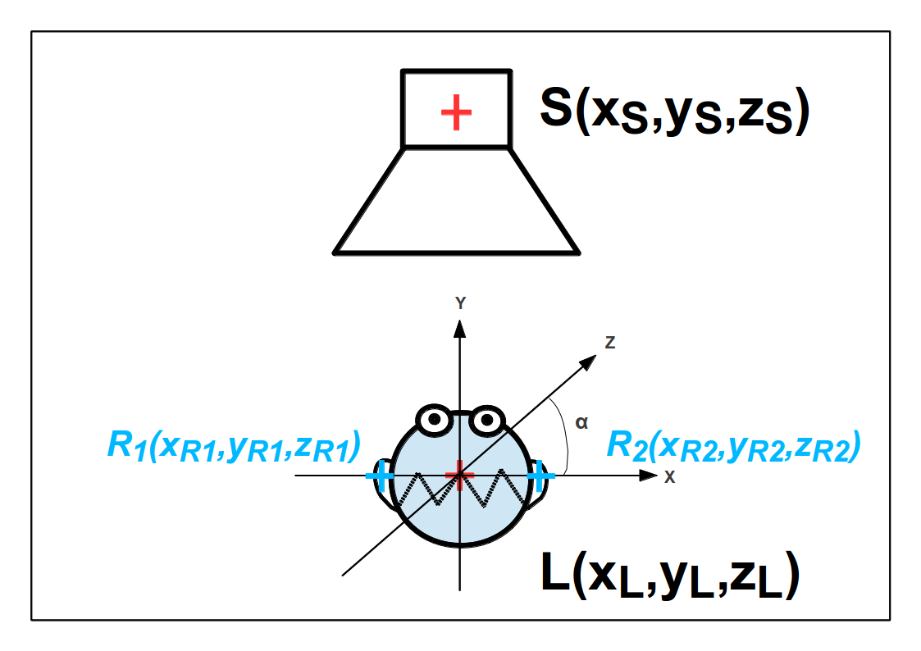Figure 1: Example of Free-field HRTF measurement
  - Receivers: 2 ears = 2 receivers, no further description;
  - Source: the loudspeaker, fixed position at a constant distance from the listener;
  - Transmitter: no information;
  - Room: no information.

- BRIR measurement at various listener positions:
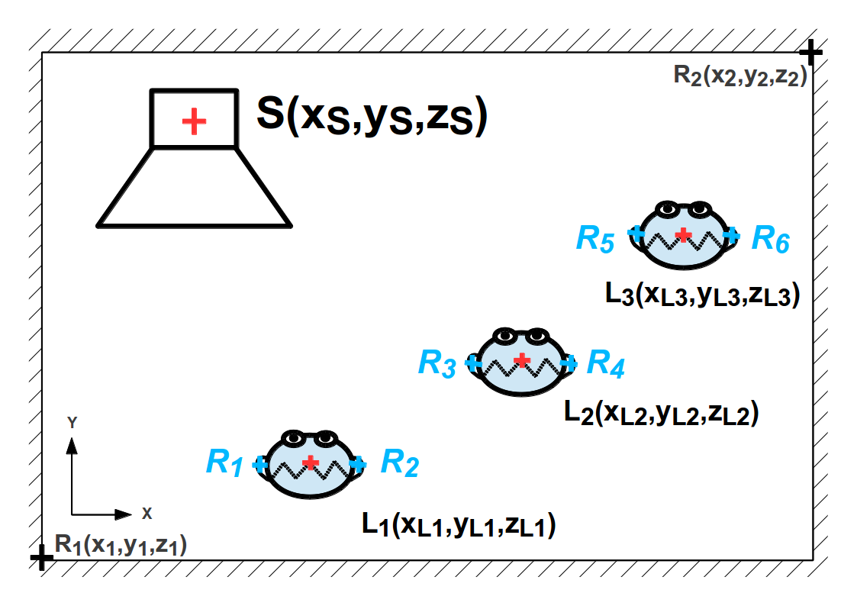Figure 2 : Example of BRIR measurement
  - Room: somehow described (simple: shoebox; complex: triangular mesh), defines the origin of the coordinate systems;
  - Listener: the head, the position and orientation vary;
  - Receivers: 2, no further information
  - Source: loudspeaker, fixed position somewhere in the room
  - Transmitter: no further information
- Mic-array measurement in a room, having a line-array of speakers as excitation; each data item describes the IR of one speaker:
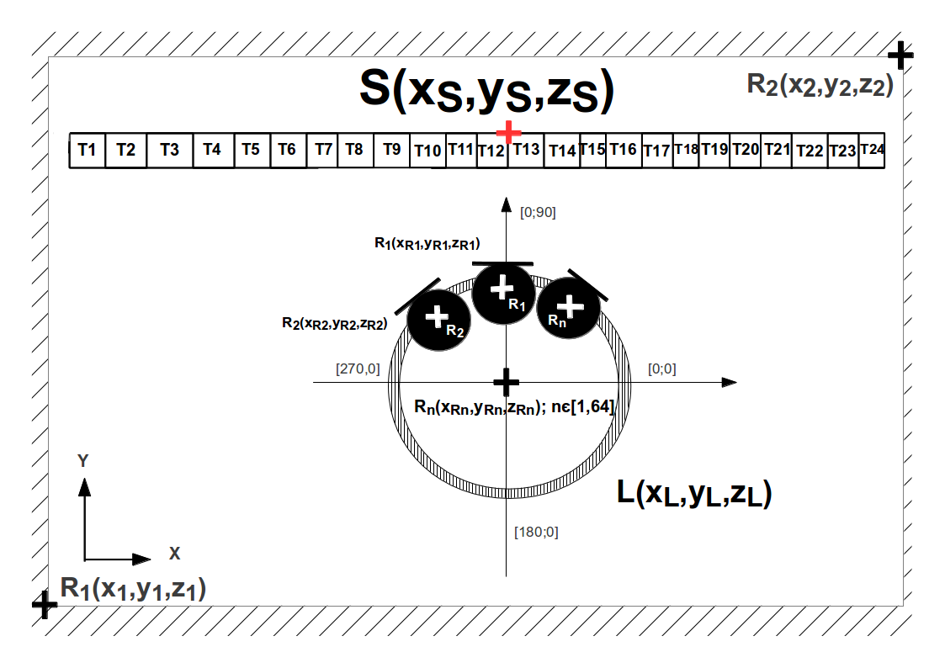Figure 3 : Example of Mic-array measurement in a room
  - Room: shoebox;
  - Listener: the array, positioned in the room, looks at the center of the speaker array;
  - Receivers: 64 mics, receiver #1 looks at the center of the speaker array, the rest described in spherical coordinate system;
  - Source: speaker array, positioned somewhere in the room, looks at the listener;
  - Transmitter: 24 speakers; #1 is left, #24 is right, center is between #12 and #13.

- BRIR measurement with variable torso (TU-Berlin setup), excitation with a saxophone, playing at different orientations:
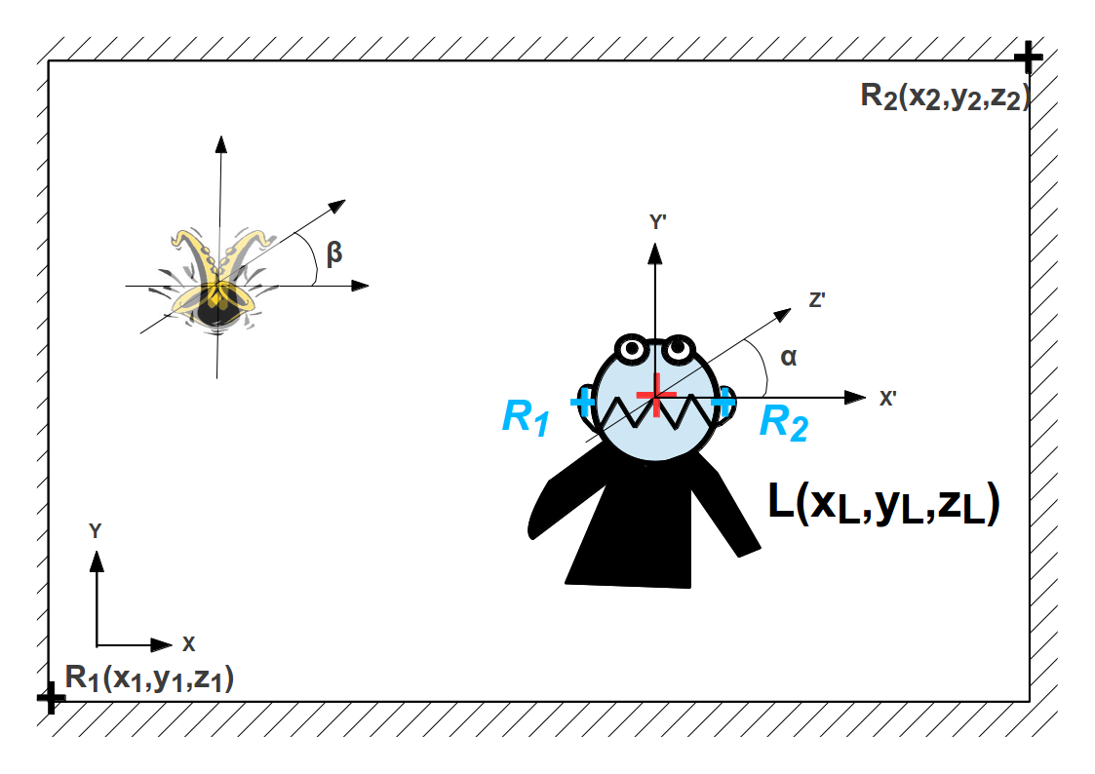Figure 4 : Example of BRIR measurement with variable torso
  - Room: some description;
  - Listener: the head, position and orientation may vary;
  - Receivers: 2; no further information;
  - Object: the torso, position: identical to the Listener's position; orientation (in global coordinate system!) may vary;
  - Source: the instrument; position fixed, orientation varies;
  - Transmitter: no further information.

- RIR as a function of the room temperature:
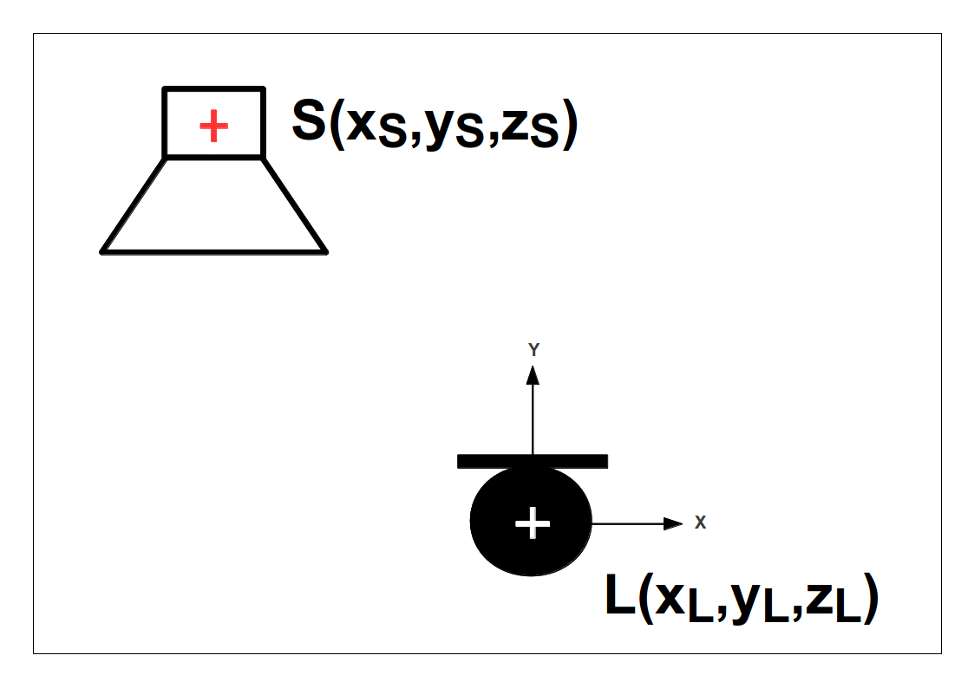Figure 5 : Example of RIR as function of the room temperature
  - Room: no further information;
  - Listener: the mic, fixed position and orientation;
  - Receiver: no further information;
  - Source: the loudspeaker, fixed position and orientation;
  - Transmitter: no further information;
  - Object: temperature, varies.

- Directivity pattern of a two-way loudspeaker (in free-field)
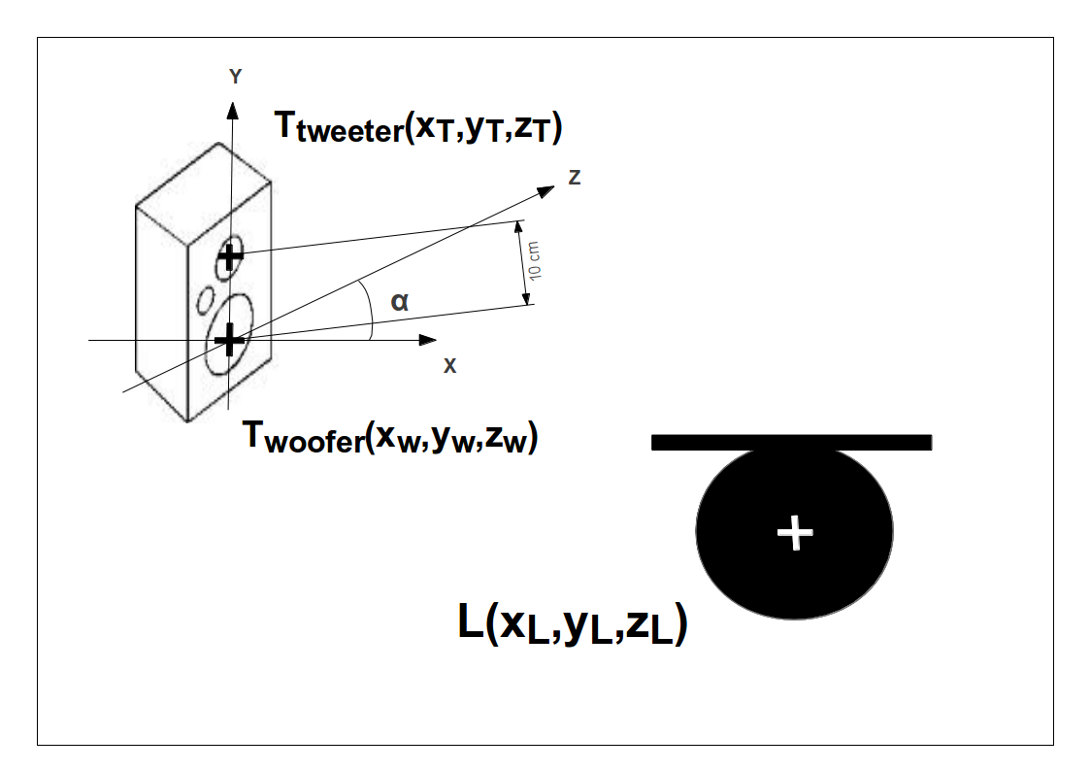Figure 6 : Example of two-way loudspeaker in free-field
  - Room: no further information;
  - Listener: the mic, fixed position and orientation;
  - Receiver: no further information;
  - Source: the loudspeaker, fixed position, orientation varies;
  - Transmitters: 2 (woofer, tweeter); position of the woofer: origin; position of the tweeter: 10 cm higher.

Coordinate types
The information about the position and orientation are stored in custom formats. The attributes “OrientationType” and “PositionType” describe the type of the coordinate system used for the description of all positions and orientations, respectively and must be one of the following:
- Cartesian: [x y z]; all fields in meter
- Spherical: [azimuth (deg, 0…360) elevation (deg, -90…+90)]; the poles are in the median plane, front is [0;0]; top is [0;90], left is [270;0]; back is [180;0]
- Navigational: [azimuth (deg, -180...+180) elevation (deg, -90...+90)]; the poles are in the median plane, front is [0;0]; top is [0;90], left is [90;0]; back is [180;0]
- VerticalPolar: [azimuth (deg, -90...+90) elevation (deg, -90...+270)]; the poles are in the median plane, front is [0;0]; top is [0;90], left is [90;0]; back is [0;180]
- HorizontalPolar: [lateral (deg, -90...+90) elevation (deg, -90...+270)]; the poles are in the horizontal plane, front is [0;0], top is [0;90], right [-90;0]; back is [0;180]
There has to be a reference direction, which joins these two coordinate systems. For example where is front in the cartesian coordinate system. I think it would be nice, to just have a reference vector, that specifies, where the frontal direction lies within the cartesian coordinates. This would be consistent with the idea of having global and local reference systems for the geometry.

Schemes
To fit the needs of different labs and ease the transition from their to our format, we define schemes of meta data and provide them as examples for the various labs. The schemes can be extended by everybody: all the schemes will be hosted on a wiki-page – new contributions are welcome and will be incorporated into the HRTF format with the assistance of the format developers.

Numerical container
All the information is stored in a numerical container and saved in a file. Our aim is to use an existing container format and to achieve a transparent access to as many applications as possible. We have the following favorites at the moment:
- HDF5 format:
  - data handling on different operation systems,
  - support of many data types,
  - excellent real-time capability because of (parallel if required) access to parts of the file,
  - huge-file support,
  - native and library-based read/write supports in Matlab,
  - native read support in Octave,
  - API available for C, C++, Java, and Fortran 77, and compile on Linux, MacOS, Windows (see here)
  - Compression with GZIP allowed. Writing compressed files with a commercial software is not explicitly allowed when using SZIP.
  - unclear how to use HDF5 in Octave.
- netCDF:
  - based on HDF5,
  - obligatory naming of dimensions
  - library-based read/write support in Matlab,
  - library-based read/write support in Octave,
  - API available for C, C++, Java, Fortran 77, and Fortran 90, and compile on Linux, MacOS. Problems on Windows with MS Visual Studio (see here)
  - disadvantages with respect to HDF5:
    - additional layer requiring binding to two formats: HDF5 and netCDF.
    - handling in Matlab not as transparent as with HDF5
    - dimensions must be named, causing separate dimension name for each matrix in the file
  - advantages with respect to HDF5:
    - write support for Octave
- CDF:
  - similar to HDF5 and netCDF, see the comparison
  - allows a multi-file representation
  - library-based read/write support in Matlab,
  - API available for C, C#, Pearl, Java, Fortran, and compile on Linux, MacOS, and Windows with MS Visual Studio (see here)
  - License: completely free even if using compression in commercial products, see here
  - Problem: there seems to be no support for octave (???)
- SDIF
  - Looks like a small brother of HDF5:
    - No compression
    - Mixed ASCII/Binary representation
    - Not very spread around various scientific organizations
  - Octave support not clear (???)
  - Advantage: IRCAM would have no need to convert/adapt

Ideas / To Do:

Next Steps:
- Clarify how HDF5 can be used in Octave After a discussion on the octave mailing list, it seems to be really hard to use the built-in HDF5 library for purposes other than the load/save commands. Hence, HDF5 is not a good option, for now.
- Work out the description of the geometry: provide some pictures
- Setup a SF project
- Implement reference APIs for arbitrary structures
- Set up the appropriate structure

Support of existing databases
The flexibility of the format is an important issue. Hence, the public HRTF databases should be checked to fit the HRTF format. All these database should be convertable to the HRTF format (the conversion functions should be provided). Note that not every data saved in the HRTF format must be convertable to one of those formats without errors.
For the AMT, an HRTF repository will be created. Within the AMT, HRTFs will be provided by downloading the required data. Once downloaded, the HRTF data will be kept in a cache.

Support of existing applications (if HDF5)
- SoundScape Renderer:
- ExpSuite: adapt the parser and some applications based on ExpSuite
- openDAFF: the HDF5 library could be included in the sources and the parser could be adapted
- Spat
- Slab3d

API (if HDF5)
The API will provide read and write functions for MATLAB and Octave. The API is kept simple: When writing to the file, the API will check for the mandatory fields and the format of the already defined data types. When reading from the file, the API will simply read from the file. The API can not support all the heterogeneous needs from the various labs, hence, no algorithms will be provided. Also, we will neither provide a viewer nor an editor: In order to view the data in terms of the numerical structure, HDF5Viewer can be used instead. In order to edit the data, MATLAB or Octave can be used – it would be hard to excel such editors. MATLAB and Octave can also be used for a graphic representation of the HRTF format by using scripts specifically customized to the own needs. For already existing specialized viewers and editors, relying on other formats, conversion functions will be provided if required.

For openDAFF we just know that it does allow to store (marked with “yes”) but we do not know how.
http://www.hdfgroup.org/hdf-java-html/hdfview/

